o

Document Code | 15799
Revision | 00

GUI
Design Input

Product Name: High Power Laser
Model: VL8

Rev. No. | Issue Details | Prepared by | Confirmed by | Approved by | Date of Issue | Signature
00 | Initial Release | Bahmaeei Sh. | PRRC  Karbasi A. | Beik Y. | 03/03/2025 |         

.

- Structural Block Diagram

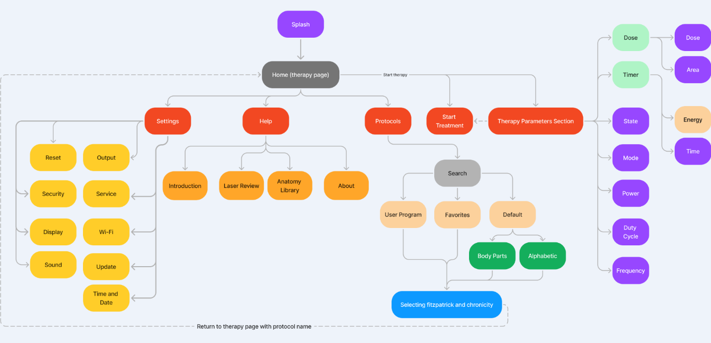

- General Design requirements
When designing a GUI for a medical device in compliance with IEC 62366-1, the focus should be on ensuring usability and minimizing use-related risks, ensuring a user-friendly interface that promotes patient safety. The design process should include a thorough analysis of user needs and capabilities, as well as the environments in which the device will be used. This involves iterative testing and validation with actual users or realistic simulations to identify potential use errors. Additionally, the layout should be intuitive, with consistent use of colors and symbols to avoid confusion, and critical information should be easily accessible. It is also essential to incorporate feedback mechanisms that alert users to errors or necessary actions. Documentation should be maintained throughout the design process, capturing risk management activities and justifications for design decisions.
To achieve this goal, considering all of the above-mentioned requirements, the device’s software should include the following items:
Note: The graphical user interface (GUI) of this device must adhere to the Portable Series format. Additionally, the device casing should follow the Portable Case design, incorporating a 7-inch touch LCD monitor for user interaction.

  - Splash Page

Once the device is turned on, it should display a splash screen. Following this, a screen should appear, prompting the user to enter the device password. If the correct password is entered, the “Home page” will open. The default password is '0000' which can be changed after accessing the device.

If the device is being turned on for the first time or after software update, the software should prompt the user to set the date and time, as well as the physiotherapist's name.

  - Home Page ( Manual therapy Page)

After the splash page, the Home page should automatically be displayed. This Home page is designed to be the central hub of the device, enabling quick and efficient operation. It should include the following key elements:
Note: All GUI pages must have a header that clearly displays the name of the current page. This ensures that users are always aware of their location within the system.

Therapy Parameters: All relevant settings and parameters for the laser therapy session should be clearly displayed and easily adjustable on this page. This allows the user to configure the treatment without navigating to a different section.
Therapy Parameters Section:
- Therapy Modes: The device shall offer multiple therapy modes. Five modes shall be available for selection, which are:
  - Continuous Wave (CW): In this mode, both Frequency and Duty Cycle settings are automatically disabled.
  - Pulsed
Note: it should be possible to set different modes for each wavelength.
- Output Mode Options (one of this options can be selected at the same time):
Timer Option: Users can manually set the Time parameter. The laser will operate based on this setting. Energy will be calculated automatically by the device based on the set time.
Dose Option: Users can set the Dose (J/cm²) and Area (cm²) parameters. The Time (min) and Energy (Joule) will be calculated automatically by the device based on these inputs.
- Time: Adjustable from 1 minute to 60 minutes with a step of 1 min, allowing precise control over the duration of each treatment session.
- Wavelength selection and Peak Power (W): The device supports a maximum output power of 8 watts, which can be fully generated by either the 1064 nm or 808 nm diode. Users can distribute the output power between both wavelengths based on treatment requirements. The peak power can be adjusted within the following ranges:
- 808 nm: 0 W to 8 W
- 1064 nm: 0 W to 8 W
- Combined Mode (Both Wavelengths): 0.1 W to 8 W (total power distribution between both sources)
- Duty Cycle: it should be possible to adjust it from 5% to 100% in 5% increments, defining the proportion of time the laser output remains active relative to the total cycle duration.

- Frequency: It should be possible to select the Frequency from 1 Hz to 1 KHz with the step of 1 for 1-10 Hz, 5 for 10-100 Hz and 50 for 100-1000 Hz.
- Area: Ranges from 1 cm² to 225 cm²; by increasing the area of the treatment, the treatment time and total Energy to be delivered will be increased.
- Dose: It ranges from 1 j/cm² to 100j/cm²; by increasing the Dose, the treatment time and total Energy to be delivered will be increased.

Start Treatment Button: A prominent button should be available for initiating the laser output directly from the Home page. This allows the user to begin the treatment quickly and efficiently after setting the necessary parameters.

Access to Other Pages:
Protocol Button: Access to predefined treatment protocols, allowing for quick application of standard therapies tailored to specific conditions. Also Favorites and user saved protocols shall be placed here.
Settings Button: Access to the Settings page for further customization of device configurations and operational parameters.
Help Button: Help section offering guidance, troubleshooting tips, and detailed instructions to support the user during operation.
Back Button: Every page within the GUI should include a "Back" button, allowing users to easily return to the previous screen.
Home Button: A "Home" button should be available on all pages, providing quick access back to the Home page at any time.
  - Protocols Page
Overview: The Protocols Page is designed to streamline the selection of treatment protocols by offering two intuitive methods of browsing: alphabetically or by body part. Also protocols created and saved by user will be shown here too. This page provides users with all necessary information to choose and customize their treatment protocol.
Sections:
- Alphabetical Protocol Selection:
  - Description: Users can browse and select protocols listed in alphabetical order.
  - Functionality: Allows quick access to known protocols based on their names.
- Body Part-Based Protocol Selection:
  - Description: Users can select protocols by interacting with a human body model displayed on the screen.
  - Functionality: Tapping or clicking on specific body parts will filter and display relevant protocols for that area.
- Favorites and User defined protocols key shall be shown in this page and by selecting each one the contents shall be shown.
- Protocol Information Display:
  - Content: Once a protocol is selected, detailed information about the treatment will be displayed, including:
    - Treatment Instructions: Step-by-step guidance for administering the therapy.
    - Visuals: Images indicating the best places to apply the treatment, helping ensure accurate and effective therapy.
- Fitzpatrick Skin Type & Chronicity Selection:
Page navigation:
After selecting a protocol, users will be directed to a page where they can specify the patient's Fitzpatrick Skin Type (6 levels, represented by Greek numerals: I to VI) and Chronicity (3 Levels: Acute, Sub-acute, Chronic). The default protocol parameters are set for the acute phase and Fitzpatrick Skin Type I to III.

Approximate effect of Chronicity on Dose Parameters:
- Acute: No adjustment to the default Dose.
- Sub-Acute: Increases the default Dose by 10-15 J/cm² by considering a constant power.
- Chronic: Increases the default Dose by 20-30 J/cm² by considering a constant power.
Approximate effect of Fitzpatrick Skin Types on Power and Duty Cycle Parameters:
- Skin Types I, II, III: No changes to Power or Duty Cycle.
- Skin Types IV, V: Power is increased by 1 watt, and the Duty Cycle is reduced by 15-20% but Dose is constant
- Skin Type VI: Power is increased by 2 watts, and the Duty Cycle is reduced by 30-40% but Dose is constant.
- Therapy Execution Page:
- Automatic Transition: After confirming the protocol and settings, the user is redirected to the Therapy Page, which mirrors the Manual Therapy Page.
- Header: Displays the selected protocol name to ensure clarity during treatment.
- Controls & Parameters: All standard therapy controls are available, allowing for adjustments if necessary before starting the treatment.
- Phase Details: The total number of phases and the current phase number should be shown.
- Remaining Time per Phase: The remaining time for the current phase should be displayed.

  - Help Page
The Help Page is designed to provide users with comprehensive support and information. It includes the following sections:
- Introduction:
  - Description: Provides an overview of the device, including its main features and how it benefits users.
  - Content: Basic usage instructions, safety precautions, and a quick start guide.
- Laser Review:
  - Description: Offers detailed information about the laser technology used in the device.
  - Content: Explanations of laser types, their therapeutic effects, and safety guidelines.
- Anatomy Library:
  - Description: A reference library that includes detailed anatomical illustrations and descriptions.
  - Content: Information on various body parts and their relevance to the treatment protocols.
- About:
  - Description: Provides background information about the manufacturer and the device.
  - Content: Version details, legal disclaimers, and contact information.
  - Settings Page
The Settings Page allows users to customize the device according to their preferences. It includes the following sections:
- Output:
  - Switch Mode: Enables users to toggle between different switch modes of operation (Toggle and momentary).
- Sound:
  - Touch Sound: Option to enable or disable sounds when interacting with the touchscreen.
  - Alarm Tone: Allows users to choose their preferred alarm tone for the end of treatment..
  - Alarm Volume: Adjustable settings for the volume of alarms.
- Reset:
  - Default Parameters: Resets therapy parameters to the original factory settings.
  - Erase Favorites: Allows users to clear all saved favorite settings.
  - Erase User Programs: Deletes all custom user-defined programs.
  - Default Settings: Resets all settings on the device to factory defaults.
- Service:
The Service Page should be designed exclusively for manufacturers to service the device, with a Password-protected access to prevent unauthorized users from entering. The page should include the following features:
- Calibration of Output: A feature that allows manufacturers to calibrate the device's output.
- Work Time: An option to show and reset or edit the timer that tracks how long the laser diode has been running, based on the after-sales services department's needs.
- Device Serial Number Entry: A feature to enter or update the device's serial number.
- Remote Software Check: An option for manufacturers to remotely access and verify the device's software.
- Display:
  - Customization Options: Allows users to personalize the device's user interface (UI).
  - Content: Options to adjust the Font, Text size, and theme (light/dark mode).
- Time and Date:
  - Description: Allows users to set or adjust the device's internal clock and calendar.
  - Content: Manual time and date setting, or synchronization with network time.
- Security:
  - Password: Provides options to set, change, or remove the password for accessing the device.
  - Interlock: Provides possibility to remove the requirement of remote interlock for running output.
- Wi-Fi:
  - Content: Options to connect to, disconnect from, or manage Wi-Fi networks.
- Update:
- Includes options for automatic updates and manual update checks.

Errors and Warnings Display:
Table 1. Alarms and warnings conditions and priorities
No. | Priority | Alarm/Warning Condition | Text to be shown | Indicator Light | Indicator Sound | Required Action
1 | High | Tapping the Start Button and Output starts running. | - | Color: Red | Yes | Laser ready for emission.
2 |  | Laser module over temperature (35º). | Over temperature. |  | Yes | Immediate Laser Emission Interruption.
3 |  | The battery or its circuit is damaged. | There is a problem in battery or its circuit. Please contact after sale service. |  | Yes | No Laser Emission Or Immediate Laser Emission Interruption.
4 | Medium | The interlock is not connected. | The interlock is not connected. | Color: Yellow | Yes | No Laser Emission.
5 |  | The handpiece optic fiber cable is not connected. | The handpiece fiber cable is not connected. |  | Yes | No Laser Emission.
6 |  | The Handswitch is not connected. | The Handswitch is not connected. |  | Yes | No Laser Emission.
7 |  | Hitting the start button when laser power is at zero. | Laser power must be greater than zero to start treatment. |  | Yes | No Laser Emission.
8 |  | Calibration failure (±20% of Preset Value). |  |  |  | No Laser Emission.
9 | Low | The entered password is wrong. | The entered password is wrong. | Color: designers choice |  | Sign-in Failure.
10 |  | A duplicated name is typed to save a user programs. | A duplicated name is typed to save a user programs. |  |  | Save Failure.
11 |  | The battery charge drops below 20%. | Low Battery |  |  | -
12 |  | Connecting the charger. | (A visual notification on the UI showing that battery is being charged.) |  | Yes | -
13 |  | High power (more than 5) in Continuous mode. | The selected power is too high, please be careful. |  |  | -

Standard Requirements

International/Local/National Standards (IEC, ISO, EN, ISIRI)
Table 11
N. | Title of Standard
1 | IEC 62304:2006/AMD1:2015  Medical Device Software- Software life cycle processes
2 | IEC 62366-1:2015+AMD1:2020  Application of usability engineering to medical devices
3 | EN ISO 14971:2019/A11:2021  Application of risk management to medical devices
4 | Medical Devices Regulation (EU) 2017/745  Medical device regulation (MDR)

